Business Requirement
Student’s Name
Course Title
May 10, 2017

Business Requirement
- Project Description
The "CPL Private Company" is a web-based business that an astute speculation pulls together conveys upheld. The CEO has allowed 60 days to say your PC data innovation open up to set up inside on the association arranging even to another office. There are today quite recently no setting up and advancement condition for you to reinforce up this business. Each information exchange needs to settle on a decision of your helped understanding, on setting feeling perhaps an intersection over the show. E-commerce, be that as it may, presents a unique test for the web page maker and the legal professional. The modern way of the innovation required quantity of players needed in setting up a web page and encouraging exchanges, the security worries of clients who might give the website data about themselves, and a large group of different substances of online business makes compelling legitimate portrayal fundamental in this field. What's more, web based business set-up regularly requires impressive speed because of the way of the firm, accordingly including an extra layer of unpredictability that calls for significantly more cautiousness and readiness on the legal specializes in organizing exchanges and exhorting customers. This segment of the course will look at some large strides that U.S. e-organizations will follow in setting up a web based business website and investigate the need or plausibility of legitimate portrayal at various primary crossroads of the set-up process (Development, 2002).
- Scope and Analysis to Control the Scope
The scope of the project defines the information about the e-commerce business as well as the estimation.
Project Scope Statement
The range of e-business is tremendous. All sorts of business capacities, for example, creation, back, showcasing and workforce organization notwithstanding administrative exercises like arranging, sorting out and controlling are brought out through PC systems. The other method for survey the extent of e-business is to investigate it regarding individuals or gatherings required in electronic exchanges. From this point of view, an organization’s electronic exchange and the system can envision as venturing into three headings. CPL Private Company is based on e-commerce business so that it have a broad field.
There are various employments of E-Commerce, for instance, home dealing with a record, shopping in electronic strip malls, buying stocks, finding an occupation, coordinating a bargaining, collaborating electronically with business associates far and wide, and giving customer advantage. The execution of various E-Commerce applications depends on upon four imperative reinforce classes, for instance, people, open approach, and advancing/publicizing and stock system collaborations. Besides, there must be an Infrastructure reinforce. The E-Commerce organization inside each affiliation arranges the applications and structure. With a particular true objective to elucidate the associations I have clarified underneath the requests because of B2C E-Commerce (Alkhalifa, 2010).
Electronic Commerce (web based business) is a term promoted by the appearance of business administrations on the Web. Web-based business is in any case, just a single some portion of the full circle of online business. One-off deals to purchasers maybe embody the corporate utilization of the Internet. Different sorts of exchanges utilize different advancements. Electronic Markets (ems) using various exchange fragments with an accentuation on hunt offices, and Electronic Information Interchange (EDI) method for consistent and institutionalized exchanges between associations. The standard of web-based business comprises of these three ranges; these speak to as a graph and plot in somewhat more detail.
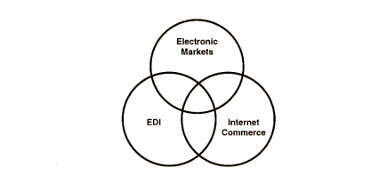
Analyze to control the E-commerce Project Scope
The organizations that are included in "ordinary" Businesses to Business B2B and Business to Client – B2C exercises progressed toward becoming businesses when the association prevails to coordinate regular activities with their electronic data framework. This electronic data structure could be an outsourcing answer for the web and versatile locales or, then again gateways or an "in-house" created a framework. For instance, somebody who works in deals division could consider the web and wap remote application convention site a deals device.
When he or she talks with a client, shows to the customer the item and administration introductions on organization's web or even wap site runs with the customer in virtual tours of the freshest items and administrations. The Marketing Department discharges items, what's more, officials on the web and wap website, to begin with, giving eLearning courses, online introductions what's more, leaflets. Another division of Customer Support have FAQ – Frequently Made inquiries, bolster visit lines, what's more, direct newsgroups on the site. Buying utilizes the web to get costs on fundamental parts and place orders, and shipping uses the internet to calendar conveyances also, tell clients of item entry (Development, 2002).
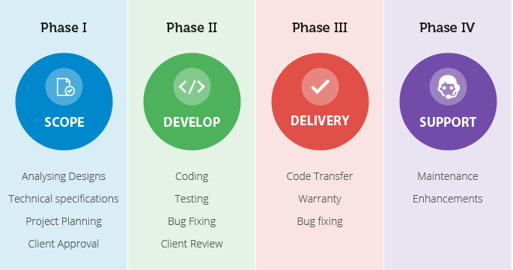
- Risks, Constraints, and Assumptions
Risk
CPL Private Company has an assortment of business and innovation drivers, and these accompanied both advantages and dangers. Building up a suitable methodology incorporates calculating in the benefits while measuring the risks, which include misrepresentation, loss of protected innovation, harmed client and accomplice connections, unanticipated costs, advertising disasters and business disturbances.
- Is a site considered publicizing?
- Is there a risk for connections on your site to other random business?
- Does D&O scope apply to suits against chiefs and officers for on-line exercises?
- Where might Professional Errors and Omissions scope kick?
- It is safe to say that you are secured for inability to obtain classified data?
- Is there scope for misfortunes maintained by people or your clients that depended on data that they read on your site?
Constraints
Time for Delivery of Physical Products
It is probable to visit an adjacent music piling up together with quit having a decreased elliptical, or even a e-book go shopping as well as get away from having a book. On-line business is seeing that often as feasible utilized to buy items that aren't start in your area by associations wherever throughout the planet, inferring that natural supply will need to spread, that requires massive opportunity and charges money. From time to time there are training in regards to this, one example is, with auto documents with the songs or textbooks get to on the Web, but then these aren't natural items (Steven Furnell, 2005).
Limited and Selected Sensory Information
The Internet is an agent course for visual and as well stable related facts: witnessing snap shots, seeing and hearing appears alongside looking at content. At any rate, it won't allow complete amount for all our possessions: we are able to observe photographs with the bouquets, on the other hand avoid seeing their own scent; we are able to observe images of a sled, though not really feel how heavy it is or maybe change. Launch, any time we are as well as review anything, we decide on what we please take a glance on as well as just what we glance including on it. This is simply not the trouble within the Internet. In the event we're shopping a motor vehicle within the Web, we'd begin to see the photographs the car dealer obtained resolved for people to view on the other hand not really the points we may check out in case we can easily find it vision in order to eye. Also, thinking about our differing possessions, we simply cannot test out the automobile to know the sound of the actual engine the way it adjustments riggings or maybe sources the actual aroma as well as really feel with the calfskin seats. There are not the same training in which the Web doesn't pass around the actual plenitude involving encounters with the world. The following nonappearance involving qualified facts takes that folks are a significant part almost daily by means of and through much more euphoric by using paying for while using the Web nonspecific issues – issues that they've noticed or maybe seasoned in advance of and approximately that there is little deficiency of lucidity, as an alternative to appear or maybe convoluted issues.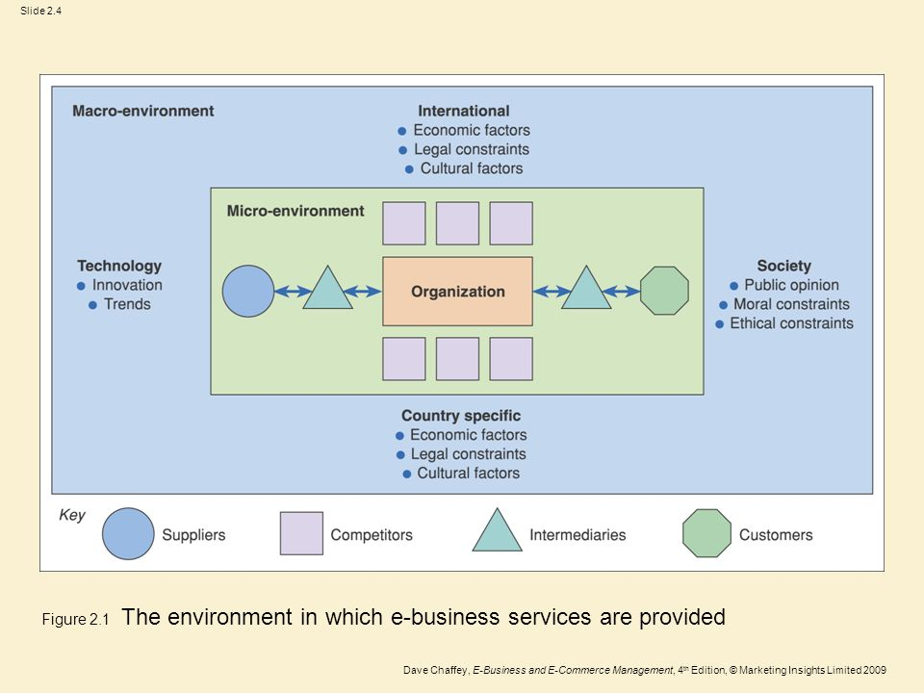

Assumptions
An assumption made on undertakings for human assets is that people will work 40 hours every week on the day move.
- That vitality assets like power will be on amid working hours.
- Material costs based a particular source.
- The general cost of everyday movement won't increment.
- Staff expenses won't change.
- General temperate conditions will remain the same (Steven Furnell, 2005).
- The Integration with Other Systems and Infrastructure

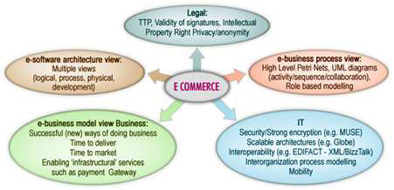
Most enterprise customers have satisfying prerequisites with regards to coordinating programming and frameworks. Once in a while does the "one size fits all" approach yield the outcomes required to manufacture and grow a client fixated business. An incredible web-based business biological community ought to never restrict to only one merchant. That is the reason we make it simple to interface Elastic Path to an extensive variety of outside business and open source programming.
For clients needing to get up and running rapidly, Elastic Path offers a few incorporation "quickening agents" which contain well-known internet business setups. These establishments cover everything from prevalent installment motors to interfacing with outside assessment consistency suppliers. Our quickening agents can diminish the time required to incorporate internet business into your IT living community. For our undertaking clients with profoundly modified necessities, Elastic Path has exceptional experience coordinating with an assortment of frameworks (A. Gunasekaran, 2001).
Infrastructure
Data Interface Design
A modern information system typically is associated with information sources that store a large measure of related information. Financial esteem, information must be effortlessly open to the clients of the data framework. It is consequently essential to give methods for seeking that are both effective what's more, simple to utilize. The outline of a capable back-end that executes look demands postures numerous issues in itself. This paper concentrates on plan options for frontend UIs that empower clients to make scan requirements and proficiently look for business information efficiently. The examples apply to both rich customer and web applications. On account of their execution many-sided quality, be that as it may, a few examples find in rich client applications (Amine, 2013).
Standard database organization endeavors kept up through the DBMS incorporate business change administration, data fortification as well as recovery and execution watching/tuning shapes. Diverse database administration strategies are in like way in charge of robotized trade rollbacks, resumes, and recuperation and furthermore the assessing and logging of the new purchaser orders. Since SQL is amazingly important, gainful and also productive in utilizing for data organization. Using SQL as DBMS stage in which SQL Queries can be utilized to get to and utilize the gigantic measures of client or agent records from a databank rapidly and proficiently. SQL offers the particularly portrayed models for the data organization. By strategies for standard SQL, it is easygoing to complete database structures prevented from securing sharing to unravel huge volume of code.

Network and Security
There is a need to introduce as well as mastermind the framework fragments like servers which control and manage the surge of data about the arrangement of your association as well as utilize the specific programming seen as NOS or Network Operating System to deal with the association orchestrates. Both the NOS and Server dually together permits the sharing of data, gear devices, for example, printers and another application programming. It resembles way controls access to information record set away in the reports. With the utilization of a couple of servers, a prospect backings to scatter the finding out workload transversely these presented sort out servers or PCs instead of over-upsetting a particular consolidated terminal in the framework.
Arrange security is a troublesome subject, for the most part simply taken care of by particularly qualified and experienced masters. Regardless, as an always expanding number of people advance toward getting to be ``wired'', a growing number of individuals need to grasp the basics of security in a sorted out world. This document creates with the principal PC customer and information structures boss as a top need, uncovering the thoughts anticipated that would scrutinize the development in the business focus and understand threats and how to oversee them. Some history of frameworks organization is consolidated along with furthermore a prolog to TCP/IP and internetworking. We proceed to consider chance government, organize perils, firewalls, and more unique reason secure frameworks administration devices (Amine, 2013).
Relevant Terms
These are a portion of the valuable and essential terms that utilize as a part of the setting of the recently created e-commerce extend according to utilized all through the business archive like as given as follow:
Information System
The information system in e-commerce is the product and equipment frameworks that bolster information concentrated applications. The diary Information Systems distributes articles concerning the outline and execution of dialects, information models, handle models, calculations, programming and equipment for data frameworks (Amine, 2013).

References
A. Gunasekaran, Y. Y.-o. (2001). Internet-based Enterprise Integration and Management: 31 October-1 November 2001, Newton, USA, Volume 4566. SPIE.
Alkhalifa, E. M. (2010). E-strategies for Resource Management Systems: Planning and Implementation. Idea Group Inc (IGI).
Amine, A. (2013). Network Security Technologies: Design and Applications: Design and Applications. IGI Global.
Development, U. N. (2002). E-commerce and Development Report 2002. United Nations Publications.
Steven Furnell, P. D. (2005). Advances in Network and Communications Engineering 2. united kingdom.

